EXP 1
#include <stdio.h>
#include <time.h>

// Iterative function for factorial
long long factorial_iterative(int n) {
long long result = 1;
for (int i = 1; i <= n; i++)
result *= i;
return result;
}

// Recursive function for factorial
long long factorial_recursive(int n) {
if (n == 0 || n == 1)
return 1;
else
return n * factorial_recursive(n - 1);
}

int main() {
int n;
clock_t start, end;
double cpu_time_used;
long long result;

printf("Enter a number to find factorial: ");
scanf("%d", &n);

// Check negative input
if (n < 0) {
printf("Factorial is not defined for negative numbers.\n");
return 1;
}

// Warning for overflow (20! fits in long long)
if (n > 20) {
printf("Warning: Result may overflow for n > 20 (long long limit).\n");
}

// Iterative timing
start = clock();
result = factorial_iterative(n);
end = clock();

cpu_time_used = ((double)(end - start)) / CLOCKS_PER_SEC;
printf("\n[Iterative] Factorial of %d = %lld", n, result);
printf("\n[Iterative] Time taken: %f seconds", cpu_time_used);
printf("\n[Iterative] Space Complexity: O(1)\n");

// Recursive timing
start = clock();
result = factorial_recursive(n);
end = clock();

cpu_time_used = ((double)(end - start)) / CLOCKS_PER_SEC;
printf("\n[Recursive] Factorial of %d = %lld", n, result);
printf("\n[Recursive] Time taken: %f seconds", cpu_time_used);
printf("\n[Recursive] Space Complexity: O(n) (recursion stack)\n");

// Added last line
printf("\n\nName: KARAN GHADGE\nPRN: 22458010105\n");

return 0;
}

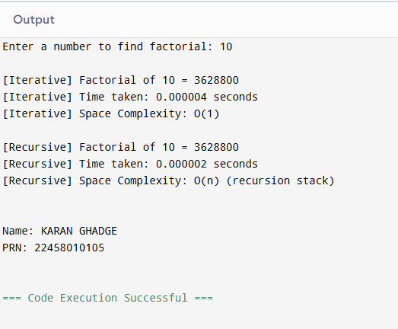

EXP 2
#include <stdio.h>
#include <time.h>

// Recursive Binary Search Function
int binarySearch(int arr[], int left, int right, int key) {
if (left > right)
return -1;

int mid = left + (right - left) / 2;

if (arr[mid] == key)
return mid;
else if (arr[mid] > key)
return binarySearch(arr, left, mid - 1, key);
else
return binarySearch(arr, mid + 1, right, key);
}

int main() {
int arr[100000], n, key, result;
clock_t start, end;
double cpu_time_used;

printf("Enter number of elements: ");
scanf("%d", &n);

if (n <= 0 || n > 100000) {
printf("Invalid number of elements!\n");
return 1;
}

printf("Enter %d elements in sorted order:\n", n);
for (int i = 0; i < n; i++) {
scanf("%d", &arr[i]);
}

printf("Enter the element to search: ");
scanf("%d", &key);

// Record start time
start = clock();
result = binarySearch(arr, 0, n - 1, key);
end = clock();

cpu_time_used = ((double)(end - start)) / CLOCKS_PER_SEC;

if (result != -1)
printf("\nElement %d found at position %d.\n", key, result + 1);
else
printf("\nElement %d not found in the array.\n", key);

printf("\nTime taken by recursive binary search: %.10f seconds", cpu_time_used);
printf("\nTheoretical Time Complexity: O(log n)");
printf("\nSpace Complexity (due to recursion stack): O(log n)\n");

// Added last line
printf("\n\nName: KARAN GHADGE\nPRN: 22458010105\n");

return 0;
}

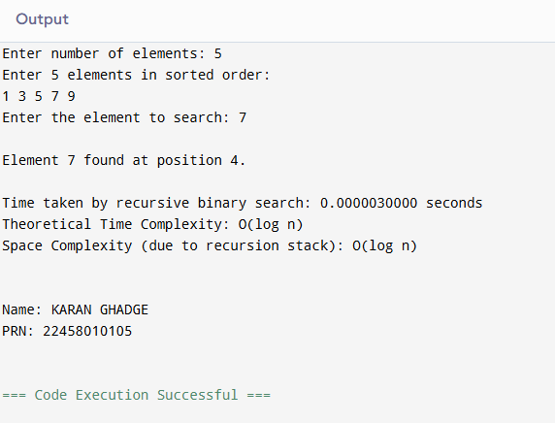

EXP 3A
#include <stdio.h>

int main() {
int arr[100], n, i, j, temp;
int swapped;

printf("Enter number of elements (max 100): ");
scanf("%d", &n);

// Validation
if (n <= 0 || n > 100) {
printf("Invalid number of elements!\n");
return 1;
}

printf("Enter %d elements:\n", n);
for (i = 0; i < n; i++) {
scanf("%d", &arr[i]);
}

// Optimized Bubble Sort
for (i = 0; i < n - 1; i++) {
swapped = 0; // Reset flag

for (j = 0; j < n - i - 1; j++) {
if (arr[j] > arr[j + 1]) {
temp = arr[j];
arr[j] = arr[j + 1];
arr[j + 1] = temp;
swapped = 1; // Swap happened
}
}

// If no swaps occurred, array is already sorted
if (swapped == 0) {
break;
}
}

printf("\nSorted array in ascending order:\n");
for (i = 0; i < n; i++) {
printf("%d ", arr[i]);
}

// Added last line
printf("\n\nName: KARAN GHADGE\nPRN: 22458010105\n");

return 0;
}
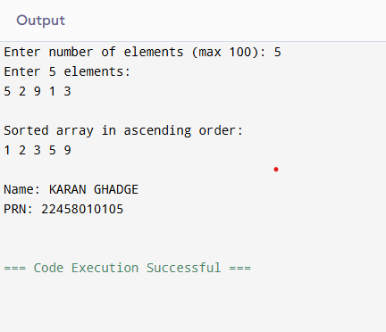

EXP 3B
#include <stdio.h>

int main() {
int array[5];
int key, j, i;

printf("Enter the values of array:\n");
for (i = 0; i < 5; i++) {
scanf("%d", &array[i]);
}

// Insertion Sort Logic
for (i = 1; i < 5; i++) {
key = array[i]; // Take current element
j = i - 1;

while (j >= 0 && array[j] > key) {
array[j + 1] = array[j];
j = j - 1;
}

array[j + 1] = key; // Insert at correct position
}

printf("\nSorted Output:\n");
for (i = 0; i < 5; i++) {
printf("%d ", array[i]);
}

// Added last line
printf("\n\nName: KARAN GHADGE\nPRN: 22458010105\n");

return 0;
}
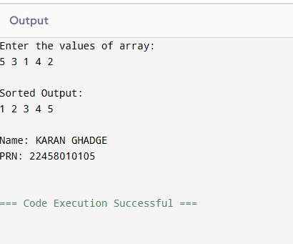

EXP 4
#include <stdio.h>
#include <stdlib.h>

struct MinHeapNode {
char data;
unsigned freq;
struct MinHeapNode *left, *right;
};

struct MinHeap {
unsigned size;
unsigned capacity;
struct MinHeapNode** array;
};

// Create new node
struct MinHeapNode* newNode(char data, unsigned freq) {
struct MinHeapNode* temp =
(struct MinHeapNode*)malloc(sizeof(struct MinHeapNode));
temp->left = temp->right = NULL;
temp->data = data;
temp->freq = freq;
return temp;
}

// Create Min Heap
struct MinHeap* createMinHeap(unsigned capacity) {
struct MinHeap* minHeap =
(struct MinHeap*)malloc(sizeof(struct MinHeap));
minHeap->size = 0;
minHeap->capacity = capacity;
minHeap->array =
(struct MinHeapNode**)malloc(capacity * sizeof(struct MinHeapNode*));
return minHeap;
}

// Swap nodes
void swapMinHeapNode(struct MinHeapNode** a,
struct MinHeapNode** b) {
struct MinHeapNode* t = *a;
*a = *b;
*b = t;
}

// Heapify
void minHeapify(struct MinHeap* minHeap, int idx) {
int smallest = idx;
int left = 2 * idx + 1;
int right = 2 * idx + 2;

if (left < minHeap->size &&
minHeap->array[left]->freq < minHeap->array[smallest]->freq)
smallest = left;

if (right < minHeap->size &&
minHeap->array[right]->freq < minHeap->array[smallest]->freq)
smallest = right;

if (smallest != idx) {
swapMinHeapNode(&minHeap->array[smallest],
&minHeap->array[idx]);
minHeapify(minHeap, smallest);
}
}

// Build Min Heap
void buildMinHeap(struct MinHeap* minHeap) {
int n = minHeap->size - 1;
for (int i = (n - 1) / 2; i >= 0; i--)
minHeapify(minHeap, i);
}

// Extract minimum node
struct MinHeapNode* extractMin(struct MinHeap* minHeap) {
struct MinHeapNode* temp = minHeap->array[0];
minHeap->array[0] =
minHeap->array[minHeap->size - 1];
--minHeap->size;
minHeapify(minHeap, 0);
return temp;
}

// Insert into heap
void insertMinHeap(struct MinHeap* minHeap,
struct MinHeapNode* minHeapNode) {
++minHeap->size;
int i = minHeap->size - 1;

while (i && minHeapNode->freq <
minHeap->array[(i - 1) / 2]->freq) {
minHeap->array[i] =
minHeap->array[(i - 1) / 2];
i = (i - 1) / 2;
}
minHeap->array[i] = minHeapNode;
}

// Build Huffman Tree
struct MinHeapNode* buildHuffmanTree(char data[],
int freq[],
int size) {
struct MinHeapNode *left, *right, *top;
struct MinHeap* minHeap = createMinHeap(size);

for (int i = 0; i < size; ++i)
minHeap->array[i] = newNode(data[i], freq[i]);

minHeap->size = size;
buildMinHeap(minHeap);

while (minHeap->size != 1) {
left = extractMin(minHeap);
right = extractMin(minHeap);

top = newNode('$', left->freq + right->freq);
top->left = left;
top->right = right;

insertMinHeap(minHeap, top);
}

return extractMin(minHeap);
}

// Print Huffman Codes
void printCodes(struct MinHeapNode* root,
int arr[], int top) {
if (root->left) {
arr[top] = 0;
printCodes(root->left, arr, top + 1);
}

if (root->right) {
arr[top] = 1;
printCodes(root->right, arr, top + 1);
}

if (!(root->left) && !(root->right)) {
printf("%c: ", root->data);
for (int i = 0; i < top; ++i)
printf("%d", arr[i]);
printf("\n");
}
}

int main() {
char arr[] = {'A', 'B', 'C', 'D', 'E', 'F'};
int freq[] = {5, 9, 12, 13, 16, 45};

int size = sizeof(arr) / sizeof(arr[0]);

struct MinHeapNode* root =
buildHuffmanTree(arr, freq, size);

int code[100], top = 0;

printf("Huffman Codes are:\n");
printCodes(root, code, top);

// Added last line
printf("\nName: KARAN GHADGE\nPRN: 22458010105\n");

return 0;
}
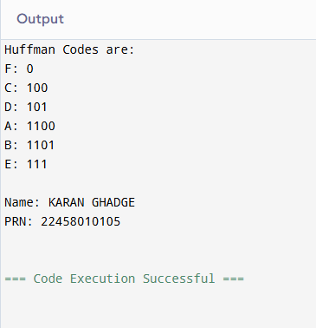

EXP 5
#include <stdio.h>
#include <stdlib.h>
#include <time.h>

#define INF 9999
#define MAX 100

// ---------- EDGE STRUCTURE ----------
typedef struct {
int u, v, w;
} Edge;

// ---------- UNION-FIND ----------
int find(int parent[], int i) {
if (parent[i] != i)
parent[i] = find(parent, parent[i]);
return parent[i];
}

void unionSets(int parent[], int u, int v) {
int uRoot = find(parent, u);
int vRoot = find(parent, v);
parent[uRoot] = vRoot;
}

// ---------- PRIM’S ALGORITHM ----------
void primMST(int cost[MAX][MAX], int n) {
int selected[MAX] = {0};
int no_edge = 0;
int totalCost = 0;

selected[0] = 1;
printf("\nPrim’s Algorithm Edges:\n");

while (no_edge < n - 1) {
int min = INF;
int x = -1, y = -1;

for (int i = 0; i < n; i++) {
if (selected[i]) {
for (int j = 0; j < n; j++) {
if (!selected[j] && cost[i][j] < min) {
min = cost[i][j];
x = i;
y = j;
}
}
}
}

if (x != -1 && y != -1) {
printf("Edge %d: (%d - %d) cost: %d\n",
no_edge + 1, x, y, cost[x][y]);
totalCost += cost[x][y];
selected[y] = 1;
no_edge++;
}
}

printf("Total cost using Prim’s Algorithm = %d\n", totalCost);
}

// ---------- KRUSKAL’S ALGORITHM ----------
void kruskalMST(int cost[MAX][MAX], int n) {
Edge edges[MAX * MAX];
int edgeCount = 0;

// Convert matrix to edge list
for (int i = 0; i < n; i++) {
for (int j = i + 1; j < n; j++) {
if (cost[i][j] != INF) {
edges[edgeCount++] = (Edge){i, j, cost[i][j]};
}
}
}

// Sort edges (Bubble Sort)
for (int i = 0; i < edgeCount - 1; i++) {
for (int j = 0; j < edgeCount - i - 1; j++) {
if (edges[j].w > edges[j + 1].w) {
Edge temp = edges[j];
edges[j] = edges[j + 1];
edges[j + 1] = temp;
}
}
}

int parent[MAX];
for (int i = 0; i < n; i++)
parent[i] = i;

int totalCost = 0, edgeAdded = 0;

printf("\nKruskal’s Algorithm Edges:\n");

for (int i = 0; i < edgeCount && edgeAdded < n - 1; i++) {
int uRoot = find(parent, edges[i].u);
int vRoot = find(parent, edges[i].v);

if (uRoot != vRoot) {
printf("Edge %d: (%d - %d) cost: %d\n",
edgeAdded + 1,
edges[i].u,
edges[i].v,
edges[i].w);

totalCost += edges[i].w;
unionSets(parent, uRoot, vRoot);
edgeAdded++;
}
}

printf("Total cost using Kruskal’s Algorithm = %d\n", totalCost);
}

// ---------- MAIN ----------
int main() {
int n, cost[MAX][MAX];

printf("Enter number of vertices: ");
scanf("%d", &n);

if (n <= 0 || n > MAX) {
printf("Invalid number of vertices!\n");
return 1;
}

printf("Enter the cost adjacency matrix (use 0 for no edge):\n");
for (int i = 0; i < n; i++) {
for (int j = 0; j < n; j++) {
scanf("%d", &cost[i][j]);

if (cost[i][j] == 0 && i != j)
cost[i][j] = INF;
}
}

clock_t start, end;
double primTime, kruskalTime;

// Timing Prim
start = clock();
primMST(cost, n);
end = clock();
primTime = ((double)(end - start)) / CLOCKS_PER_SEC;

// Timing Kruskal
start = clock();
kruskalMST(cost, n);
end = clock();
kruskalTime = ((double)(end - start)) / CLOCKS_PER_SEC;

printf("\nExecution Time Comparison:\n");
printf("Prim’s Algorithm Time: %.10f seconds\n", primTime);
printf("Kruskal’s Algorithm Time: %.10f seconds\n", kruskalTime);

// Added last line
printf("\nName: KARAN GHADGE\nPRN: 22458010105\n");

return 0;
}

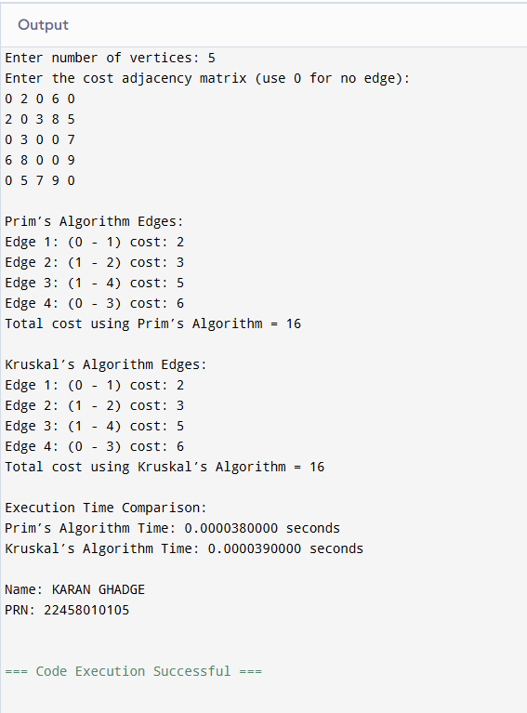

EXP 6
#include <stdio.h>

// Function to return maximum of two numbers
int max(int a, int b) {
return (a > b) ? a : b;
}

// Function to solve 0/1 Knapsack using Dynamic Programming
int knapSack(int W, int wt[], int val[], int n) {
int i, w;
int K[n + 1][W + 1];

// Build table K[][] in bottom-up manner
for (i = 0; i <= n; i++) {
for (w = 0; w <= W; w++) {
if (i == 0 || w == 0)
K[i][w] = 0;
else if (wt[i - 1] <= w)
K[i][w] = max(val[i - 1] +
K[i - 1][w - wt[i - 1]],
K[i - 1][w]);
else
K[i][w] = K[i - 1][w];
}
}

// Display DP Table
printf("\nDynamic Programming Table:\n");
for (i = 0; i <= n; i++) {
for (w = 0; w <= W; w++) {
printf("%3d ", K[i][w]);
}
printf("\n");
}

return K[n][W]; // Final maximum value
}

int main() {
int val[20], wt[20], W, n, i;

printf("Enter number of items: ");
scanf("%d", &n);

if (n <= 0 || n > 20) {
printf("Invalid number of items!\n");
return 1;
}

printf("Enter values (profits) of %d items:\n", n);
for (i = 0; i < n; i++) {
scanf("%d", &val[i]);
}

printf("Enter weights of %d items:\n", n);
for (i = 0; i < n; i++) {
scanf("%d", &wt[i]);
}

printf("Enter capacity of Knapsack: ");
scanf("%d", &W);

int maxValue = knapSack(W, wt, val, n);

printf("\nMaximum value that can be put in the knapsack = %d\n", maxValue);

// Added last line
printf("\nName: KARAN GHADGE\nPRN: 22458010105\n");

return 0;
}
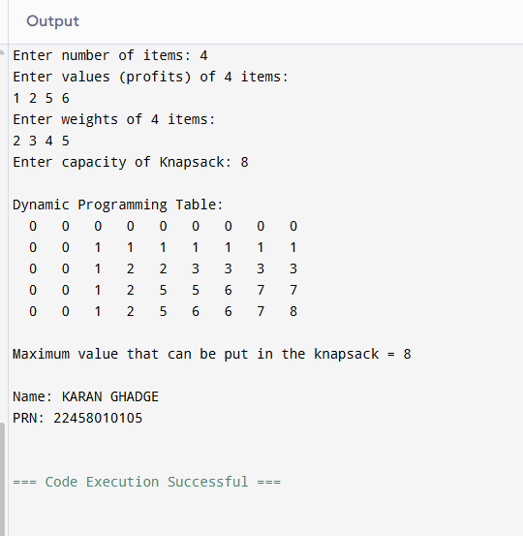

EXP 7
#include <stdio.h>
#include <string.h>

// Function to return maximum of two numbers
int max(int a, int b) {
return (a > b) ? a : b;
}

// Function to find LCS length
void LCS(char X[], char Y[], int m, int n) {
int dp[m + 1][n + 1];

for (int i = 0; i <= m; i++) {
for (int j = 0; j <= n; j++) {
if (i == 0 || j == 0)
dp[i][j] = 0;
else if (X[i - 1] == Y[j - 1])
dp[i][j] = dp[i - 1][j - 1] + 1; // FIXED
else
dp[i][j] = max(dp[i - 1][j], dp[i][j - 1]);
}
}

printf("Length of LCS is %d\n", dp[m][n]);
}

int main() {
char X[] = "AGGTAB";
char Y[] = "GXTXAYB";

int m = strlen(X);
int n = strlen(Y);

LCS(X, Y, m, n);

// Added last line
printf("\nName: KARAN GHADGE\nPRN: 22458010105\n");

return 0;
}
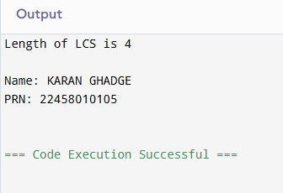

EXP 8
#include <stdio.h>

#define MAX 10

int adj[MAX][MAX], visited[MAX], n;

// BFS Function
void bfs(int start) {
int queue[MAX], front = 0, rear = 0;

visited[start] = 1;
queue[rear++] = start;

printf("BFS Traversal: ");

while (front < rear) {
int node = queue[front++];
printf("%d ", node);

for (int i = 0; i < n; i++) {
if (adj[node][i] == 1 && !visited[i]) {
queue[rear++] = i;
visited[i] = 1;
}
}
}
printf("\n");
}

// DFS Function
void dfs(int start) {
printf("%d ", start);
visited[start] = 1;

for (int i = 0; i < n; i++) {
if (adj[start][i] == 1 && !visited[i]) {
dfs(i);
}
}
}

int main() {
int i, j, start;

printf("Enter number of vertices (max %d): ", MAX);
scanf("%d", &n);

if (n <= 0 || n > MAX) {
printf("Invalid number of vertices!\n");
return 1;
}

printf("Enter adjacency matrix:\n");
for (i = 0; i < n; i++) {
for (j = 0; j < n; j++) {
scanf("%d", &adj[i][j]);
}
}

printf("Enter starting vertex (0 to %d): ", n - 1);
scanf("%d", &start);

if (start < 0 || start >= n) {
printf("Invalid starting vertex!\n");
return 1;
}

// BFS
for (i = 0; i < n; i++)
visited[i] = 0;
bfs(start);

// DFS
for (i = 0; i < n; i++)
visited[i] = 0;
printf("DFS Traversal: ");
dfs(start);
printf("\n");

// Added last line
printf("\nName: KARAN GHADGE\nPRN: 22458010105\n");

return 0;
}
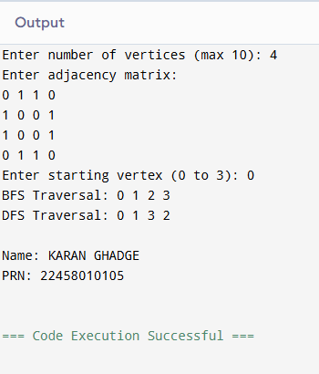

EXP 9
#include <stdio.h>

#define V 4
#define INF 99999

// Function to print distance matrix
void printSolution(int dist[V][V]) {
printf("\nShortest distances between every pair of vertices:\n\n");

for (int i = 0; i < V; i++) {
for (int j = 0; j < V; j++) {
if (dist[i][j] == INF)
printf("%7s", "INF");
else
printf("%7d", dist[i][j]);
}
printf("\n");
}
}

// Floyd–Warshall Algorithm
void floydWarshall(int graph[V][V]) {
int dist[V][V];

// Step 1: Copy input graph into dist[][]
for (int i = 0; i < V; i++)
for (int j = 0; j < V; j++)
dist[i][j] = graph[i][j];

// Step 2: Update shortest paths
for (int k = 0; k < V; k++) {
for (int i = 0; i < V; i++) {
for (int j = 0; j < V; j++) {
if (dist[i][k] != INF && dist[k][j] != INF &&
dist[i][k] + dist[k][j] < dist[i][j]) {
dist[i][j] = dist[i][k] + dist[k][j];
}
}
}
}

// Step 3: Print result
printSolution(dist);
}

int main() {
int graph[V][V] = {
{0, 5, INF, 10},
{INF, 0, 3, INF},
{INF, INF, 0, 1},
{INF, INF, INF, 0}
};

printf("Floyd–Warshall Algorithm Implementation\n");
printf("---------------------------------------\n");

floydWarshall(graph);

// Added last line
printf("\nName: KARAN GHADGE\nPRN: 22458010105\n");

return 0;
}
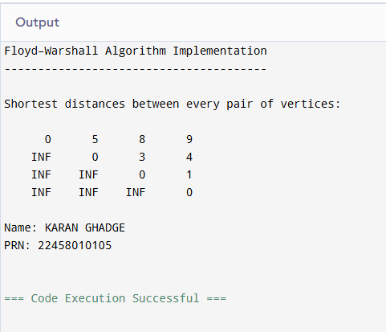

EXP 10
#include <stdio.h>
#include <stdbool.h>

#define N 4 // Number of cities
#define INF 9999

int costMatrix[N][N] = {
{0, 10, 15, 20},
{10, 0, 35, 25},
{15, 35, 0, 30},
{20, 25, 30, 0}
};

int visitedAll = (1 << N) - 1;
int dp[1 << N][N]; // DP for memoization

// ---------- Exact TSP using DP + Bitmask ----------
int tspExact(int mask, int pos) {
if (mask == visitedAll)
return costMatrix[pos][0]; // return to start
if (dp[mask][pos] != -1)
return dp[mask][pos];

int ans = INF;
for (int city = 0; city < N; city++) {
if ((mask & (1 << city)) == 0) {
int newAns = costMatrix[pos][city] + tspExact(mask | (1 << city), city);
if (newAns < ans) ans = newAns;
}
}

dp[mask][pos] = ans;
return ans;
}

// ---------- Approximate TSP using Nearest Neighbor ----------
int tspApprox() {
bool visited[N] = {false};
int totalCost = 0;
int current = 0; // Start from city 0
visited[0] = true;
printf("\nNearest Neighbor Path: 0");

for (int count = 1; count < N; count++) {
int nearest = -1;
int minDist = INF;
for (int j = 0; j < N; j++) {
if (!visited[j] && costMatrix[current][j] < minDist && costMatrix[current][j] != 0) {
minDist = costMatrix[current][j];
nearest = j;
}
}
visited[nearest] = true;
totalCost += minDist;
current = nearest;
printf(" -> %d", current);
}

totalCost += costMatrix[current][0];
printf(" -> 0\n");

return totalCost;
}

// ---------- MAIN ----------
int main() {
// Initialize DP table
for (int i = 0; i < (1 << N); i++)
for (int j = 0; j < N; j++)
dp[i][j] = -1;

printf("Traveling Salesperson Problem (TSP) Comparison\n");
printf("----------------------------------------------\n");

int exactCost = tspExact(1, 0);
int approxCost = tspApprox();

double errorPercent = ((double)(approxCost - exactCost) / exactCost) * 100.0;

printf("\nOptimal (Exact) TSP Cost = %d", exactCost);
printf("\nApproximate (Nearest Neighbor) TSP Cost = %d", approxCost);
printf("\nApproximation Error = %.2f%%\n", errorPercent);

// Added last line
printf("\nName: KARAN GHADGE\nPRN: 22458010105\n");

return 0;
}
